INSTALLATION & OPERATIONAL MANUAL
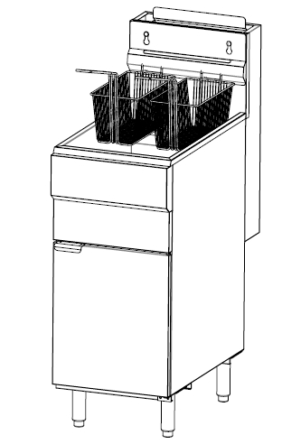
IMPORTANT FOR YOUR SAFETY
THIS MANUAL HAS BEEN PREPARED FOR PERSONNEL QUALIFIED TO INSTALL GAS EQUIPMENT, WHO SHOULD PERFORM THE INITIAL FIELD START-UP AND ADJUSTMENTS OF THE EQUIPMENT COVERED BY THIS MANUAL.
POST IN A PROMINENT LOCATION THE INSTRUCTIONS TO BE FOLLOWED IN THE EVENT THE SMELL OF GAS IS DETECTED. THIS INFORMATION CAN BE OBTAINED FROM THE LOCAL GAS SUPPLIER.
IMPORTANT
IN THE EVENT A GAS ORDOR IS DETECTED, SHUT DOWN UNITS AT THE MAIN SHUTOFF VALVE AND CONTACT THE LOCAL GAS COMPANY OR GAS SUPPLIER FOR SERVICE.
FOR YOUR SAFETY
DO NOT STORE OR USE GASOLINE OR OTHER FLAMMABLE VAPORS OR LIQUIDS IN THE VICINITY OF THIS OR ANY OTHER APPLIANCE.
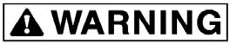
Improper installation, adjustment, alteration, service or maintenance can cause property damage, injury or death. Read the installation, operating and maintenance instructions thoroughly before installing or servicing this equipment.
Using the appliance safely
Being an appliance designed only for professional use, it should be operated by qualified personnel exclusively.
Never leave the appliance unattended while it is on.
Do not move the appliance while hot.
Do not replenish the tank while the oil is hot. Please pay attention to the oil level mark when filling the tank. If it is below the minimum line, the oil might catch fire. If it is over the maximum line, the oil might overspill. It must be somewhere between min and Max line.
Please make sure the food is not wet. If food is wet or water drops inside the oil or fat, oil would burst and it is extremely dangerous.
Do not use flammable solvents or cleaning aids to clean this fryer. Corrosion might occur.

Safety instructions in case of malfunction
If the appliance will remain idle for some time or in the event of a failure, abnormal operation, etc., turn off the shutoff valve upstream of the appliance. Call the service.
Additional prohibitions (hazardous procedures)
Never tamper with the seals of the adjusting screws located on the gas valves.
Disposing of the appliance
This appliance has been manufactured using recyclable raw materials and does not contain any hazardous or toxic substances. To dispose of the appliance and all its packaging materials, strictly follow the local regulations in force in the place where it is installed. Packaging materials should be divided according to the type and delivered to a specific collection site. Ensure compliance with environmental protection regulations.

TABLE OF CONTENTS
Important for your safety
Introduction
General
Specifications
Installation
Clearances
Location
ASSEMBLY
Flue connection
Gas connection
Gas pressure
Test gas supply
Leveling the fryer
Operation
Over temperature shutdown
Before first use
Cleaning
Filling the tank with shortening
Lighting the pilot
Turning on the fryer
Turning off the fryer
Extended shutdown
Basic frying instructions
Fry Basket Guidelines
Extended shortening life
Daily filtering
CLEANING Daily
Bolt out procedure
Maintenance
Flue vent inspection
Troubleshooting

INTRODUCTION
GENERAL
This type of Fryer is produced with quality workmanship and material. Proper installation, usage and maintenance will result in years of satisfactory performance.
Before installing the fryer, thoroughly read this manual and carefully follow all instruction.
This manual is applicable to model listed on the cover page. Procedures in this manual will apply to all models unless specified. Pictures and illustrations can be of any model unless the picture or illustration needs to be model specific.
Specification

MODEL | Burner Qty | Type of gas | KW/ Hour | Width Inch | Shortening lbs.
GF90 | 3 | G20,G30,G31 | 26.4 | 15.5" | 35-40
GF120 | 4 | G20,G30,G31 | 35.2 | 15.5" | 45-50
GF120T | 4 | G20,G30,G31 | 35.2 | 15.5" | 25+25
GF150 | 5 | G20,G30,G31 | 44 | 21.0" | 65-70
GF85 | 5 | G20,G30,G31 | 44 | 21.0" | 85-90
Specification
MODEL | Burner Qty | Type of gas | KW/ Hour | Width Inch | Shortening lbs.
GF90 | 3 | G25.3 | 25.5 | 15.5" | 35-40
GF120 | 4 | G25.3 | 34 | 15.5" | 45-50
GF120T | 4 | G25.3 | 34 | 15.5" | 25+25
GF150 | 5 | G25.3 | 42 | 21.0" | 65-70
GF85 | 5 | G25.3 | 42 | 21.0" | 85-90

INSTALLATION
Before installing the fryer, verify that the type of gas (natural or propane) agrees with the specifications on the fryer naming plate which is located at the rear part of the unit. Make sure the fryer is configured for the proper elevation.
Record your fryer model, device, and serial numbers for future reference in the space provided below. This information can be found on the fryer data plate.

Model No: ___________________
Device: ______________________
Serial No: ____________________

Clearances
☆ | Minimum clearance from combustible construction:
 | 6” (15 cm) from the sides of the fryer 6” (15 cm) from the back of the fryer The fryer may be installed on combustible floors
☆ | Minimum clearance from noncombustible construction:
 | 0” from the sides of the fryer 0” from the back of the fryer
☆ | Between the fryer and any open-top flame units:
 | 16” (41 cm)

Location
☆ Install fryer in an area with sufficient air supply for gas combustion at fryer burners.
☆ Do not obstruct the flow of combustion and ventilation air.
☆ Provide adequate clearance for air openings into the combustion chamber.
☆ Do not permit fans to blow directly onto fryer.
☆ Avoid wall-type fans, which create cross-currents within a room. Avoid open windows next to sides or back.

ASSEMBLY
The fryer must be restrained to prevent tipping and the splashing of hot liquid. The means of restraint may be the manner of installation, such as connection to a battery of appliances, installing the fryer in an alcove, or by separate means such as adequate ties.
FLUE CONNECTION
Make the flue connection as follows:
☆ Locate the fryer under a hood with adequate connection to an exhaust duct. The hood must extend 6” (15 cm) beyond fryer on both sides.
☆ Clearance above the fryer should be adequate for combustion by-products to be removed efficiently.
☆ An 18” (46 cm) minimum clearance should be maintained between the flue vent and the filters of the hood venting system.
☆ Never make flue connections directly to the fryer.
☆ Do not obstruct the flow of the gases from the appliance. Proper air balance should be maintained in the room.
GAS CONNECTION
All gas supply connections and any pipe joint compound must be resistant to the action of propane gases.
The gas inlet is located on the lower rear of the fryer. Codes require that a gas shutoff valve be installed in the gas line ahead of the fryer.
The gas supply line must be at least the equivalent of ½” (12.7 mm) iron pipe for single units and 1-1/4” (31.75 mm) for batteries. If using the optional quick-disconnect flex hose, ¾” (19 mm) iron pipe for single units and 1-1/4” (31.75 cm) iron pipe for batteries.
Make sure the pipes are clean and free of obstructions, dirt, and piping compound. A battery requires one or two connections of appropriate size for the gas requirement.

Prior to lighting, check all joints in the gas supply line for leaks. Use soap and water solution. Do not use an open flame.
After piping has been checked for leaks, fully purge gas pipes to remove air.
GAS PRESSURES (ALL MODELS):
The available gas pressure should be the same as that indicated on naming plate. If incoming pressure exceeds 5 kPa, an additional pressure regulator must be installed.

TESTING THE GAS SUPPLY PIPING SYSTEM:
When test pressures exceed 5 kPa, the fryer and its individual shutoff valve must be disconnected from the gas supply piping system.
LEVELING THE FRYER
Check the level of the fryer by placing a level on top of the fryer after gas connections have been made. Ensure that the fryer is level front-to-back and side-to-side in the final installed position. If using casters, lock the wheels after unit is level.

Air adjustment
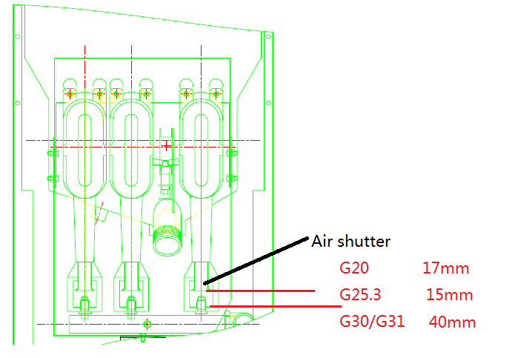
Unscrew the locking screw of the burner air shutter and adjust the air shutter to desired height. In the above picture you can find the suggested height for different types of gases. The height is the distance between burner base and air shutter.

OPERATION
Hot oil and parts can cause burns. Use care when operating, cleaning and servicing the fryer.

Spilling hot frying compound can cause severe burns. Do not move fryer without draining all frying compound from the tank.

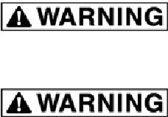

OVER-TEMPERATURE SHUTDOWN
If the shortening becomes overheated, a high-temperature shutoff device will turn the gas valve off and extinguish the pilot.
If the fryer shuts down due to overheating, DO NOT re-light the pilot until the shortening temperature is below 149 ℃(300 ℉)
If an overheating situation persists, contact qualified technician for help.
BEFORE FIRST USE
Cleaning
New units are wiped down at the factory to remove any visible signs of dirt, oil, grease, etc. remaining from the manufacturing process.
Before any food preparation, thoroughly wipe protective oil from all surface parts and the tank interior with hot soapy water to remove any film residue and dust or debris.
Do not use chlorine or sulfate/sulfide cleaners.
- Wash any accessories shipped with unit.
- Rinse fryer and accessories thoroughly and drain the fryer. Š Wipe tank completely dry with a soft, clean cloth.

FILLING TANK WITH SHORTENING
Solid shortening should NOT be used with this type of fryer. Melting solid shortening will damage the tank.
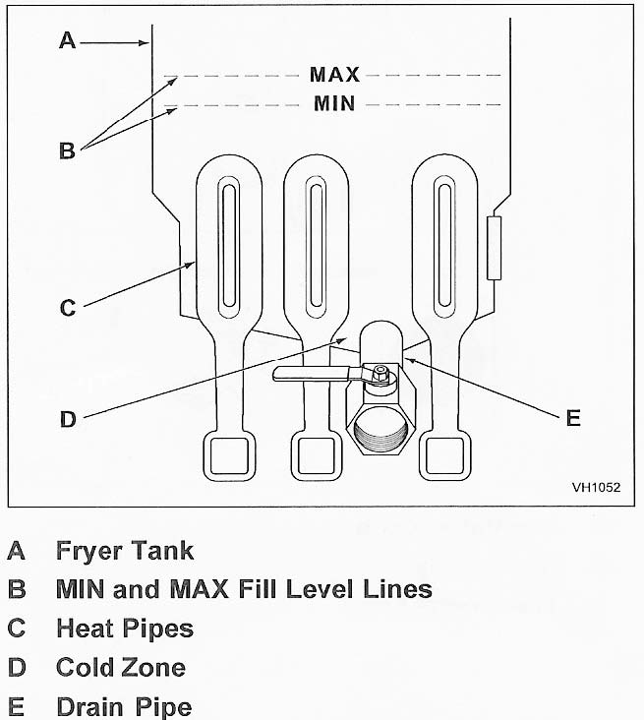
☆ | Close the drain valve.
☆ | Fill the fryer tank with liquid shortening.
☆ | Shortening level should be between the min and max lines in the fryer tank.
☆ | Shortening will expand when heated. Do not ill the fryer tank past the
☆ | MAX line.
☆ | Add fresh shortening as needed to maintain oil level.

LIGHTING THE PILOT
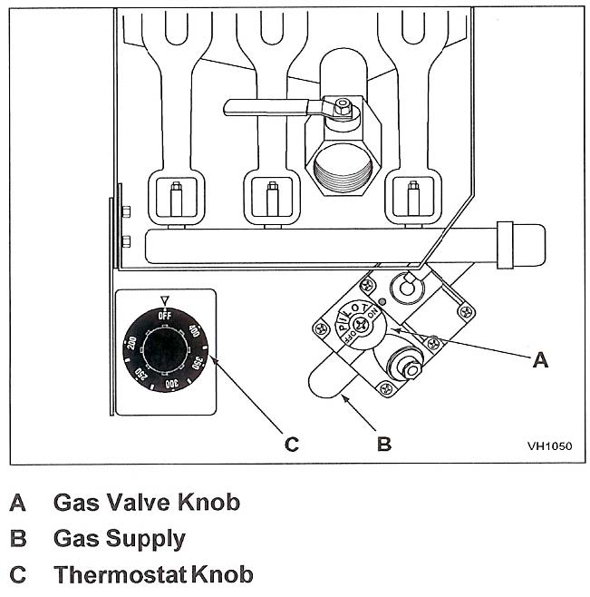
1. Open the door.
- Turn the thermostat OFF (see figure below, view A). The thermostat is located behind the door.
- Push the gas control valve knob and turn to OFF. Wait 5 minutes for unburned gas to vent.
- Push and turn gas control valve knob to the “L” in PILOT (see figure below, view B).
- While still holding the knob in, light the pilot with a lit flame. Continue to depress the knob until pilot remains lit when knob is released. If the pilot does not remain lit, repeat step 3 through 5.
- Depress and turn gas control knob to ON (See figure below, view C).
- If gas supply is interrupted, repeat steps 2 through 6.

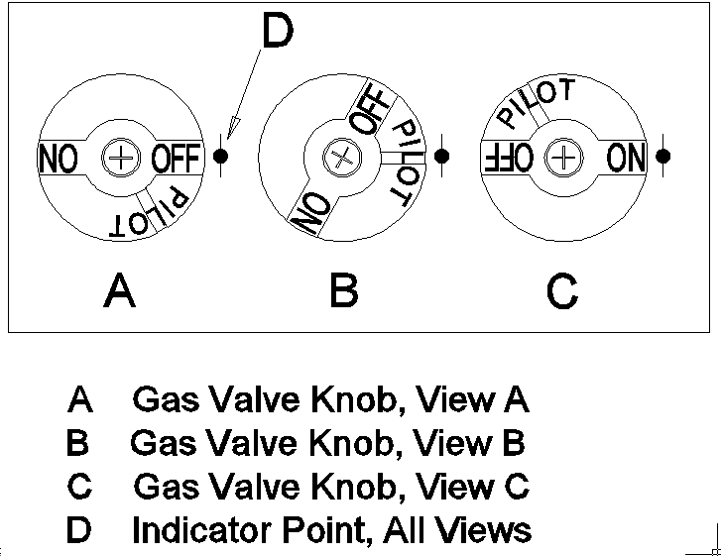
TURNING ON THE FRYER
1. Set the temperature knob to desired temperature.
2. After the set temperature has been reached, the thermostat shuts off the gas flow to burners.
3. The pilot remains lit. The burners will cycle on and off, maintaining the set temperature.
TURNING OFF THE FRYER
1. Turn the thermostat OFF.
2. To keep the pilot lit, turn the gas valve to “L” in Pilot.
3. To shut off all gas to the system, including the pilot, turn the gas valve knob to OFF.

EXTENDED SHUTDOWN
1. Turn the thermostat knob to OFF.
2. Push in the pilot knob and turn to OFF.
3. Thoroughly drain the fryer. Refer to DRAINING THE FRYER.
4. Clean the fryer according to CLEANING.
5. Turn off the main gas shutoff valve.

BASIC FRYING INSTRUCTION

Set the desired temperature and allow shortening to heat up to that temperature.
Fry items that are about the same size together to ensure equal doneness.
Drain or wipe dry raw or wet foods to minimize splatter when lowering into hot shortening.
Add fresh shortening as needed.
Fry Basket Guidelines
Do not overfill baskets. Carefully lower basket into oil.
When frying doughnuts and fritters, turn product only once during frying.
When cooking French fries or onion rings, shake the basket several times in a way that does not splatter the shortening.
Batter-covered foods should be dropped carefully, one by one, into shortening or basket. If you use the basket, first dip the basket into the shortening to reduce batter-build up on basket surfaces.
When frying is completed, remove basket or product. Hang basket on rear hanger.

EXTENDING SHORTENING LIFE
Shortening life can be extended by the following guidelines:
- Do not salt foods over the fryer.
- Use good-quality shortening.
- Filter shortening daily (at a minimum).
- Replace shortening if it becomes poorly flavored.
- Keep equipment and surrounding clean.
- Set thermostat correctly.
- Remove excess moisture and particles from food products before placing on fryer.
DRAINING THE TANK
1. Turn the thermostat to OFF.
2. To keep the pilot lit, turn the gas valve to PILOT.
3. Direct the drain spout into the container that you want to drain the shortening into.
4. Open the drain valve. The oil will drain into the container. When the container is full or the fryer tank is empty, close the drain valve. Repeat this step until the fryer is empty.
5. If desired, perform the weekly clean-out as described under CLEANING.
6. Once tank is completely empty, add new shortening and set thermostat to desired temperature.

DAILY FILTERING
Hot oil and hot parts can cause burns. Use care when operating, cleaning, and servicing the fryer.
☆ Filter shortening at least once a day. Refer to the instructions provided with your filtering equipment.
☆ A cold fryer will not drain properly. Always filter shortening between 250F and 350F. The shortening in the cold zone area will remain hard if the heat is only on for a few minutes. If necessary, use the clean-out rod to carefully stir the hard shortening to an area above the cold zone where it will melt. Use the tank brush to help clear sides and tubes of debris.
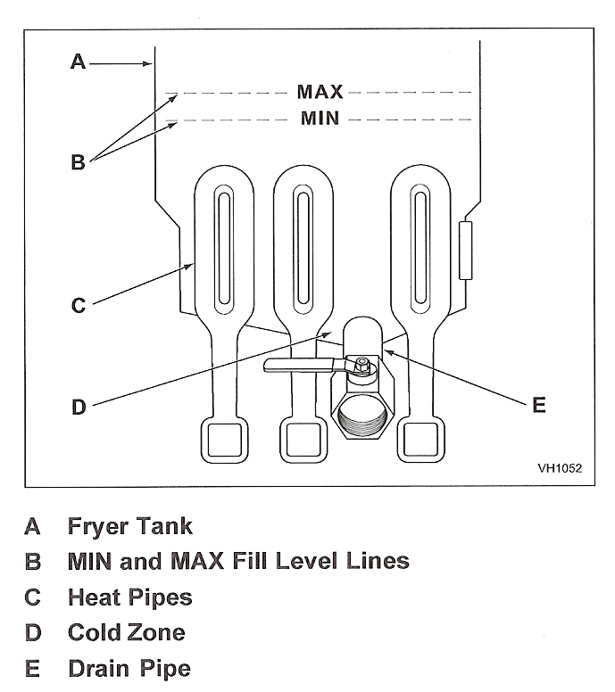
CLEANING
Hot oil and hot parts can cause burns. Use care when operating, cleaning, and servicing the fryer.
Daily
Clean your fryer regularly with the tank brush along with a damp cloth, and polish with a soft dry cloth. If regular cleaning is neglected, grease will be burned on and discolorations may form.
Fingerprints are sometimes a problem on highly polished surfaces of stainless steel. They can be minimized by applying a cleaner that will leave a thin oily or waxy film.
- Clean all exterior surfaces of your fryer at least once daily.
- Use a damp cloth with warm water and a mild soap or detergent.
Do not use chlorine or sulfate/sulfide cleaners.
- Rinse thoroughly, and then polish with a soft dry cloth.
- Keep the fryer exterior clean and free of accumulated grease to prevent stubborn stains from forming. If regular cleaning is neglected, grease will be burned on and discolorations may form.
- Remove discolorations by washing with any detergent or soap and water.
- Use a self-soaping, non-metallic scouring pad for particularly stubborn discolorations.
- Always rub with the grain of the stainless steel. Š Do not use a metallic scoring pad or harsh cleaners.
BOIL OUT PROCEDURE
Weekly or as required:
- Drain the tank as described under DRAINING THE TANK.
- Once the shortening has been drained, flush out scraps and sediment with a small amount of warm shortening, using tank brush. Allow the tank to drain thoroughly.
- Close the drain valve and fill tank with non-corrosive, grease-dissolving commercial cleaner. Follow the manufacture’s instructions.
Do not use chlorine or sulfate/sulfide cleaners.
- Add commercial boil-out solution. Solution level must be between the MIN and MAX levels on the fryer tank.
- Set thermostat to the temperature recommended for the solution being used. Allow solution to simmer for about 15 to 20 minutes.
- Drain the cleaning solution from the tank.
- Close the drain valve and refill the tank with water. Add 1 cup (1/4 L) of vinegar to neutralize alkaline left by the cleaner. Solution level must be between the MIN and MAX level on the fryer tank.
- Bring the solution to a simmer only, turn the thermostat off. Allow to stand for a few minutes.
- Drain the tank according to DRAINING THE TANK. Rinse thoroughly with clear, hot water. All traces of cleaner must be removed. Dry the tank thoroughly.
- Close the drain valve and add shortening. Follow the FILLING TANK WITH SHORTENING procedure in this manual. The fryer is now ready for use.

MAINTENANCE
Hot oil and hot parts can cause burns. Use care when operating, cleaning, and servicing the fryer.

Spilling hot fryer compound can cause severe burns. Do not move fryer without draining all frying compound from the tank.

FLUE VENT INSPECTION
When the fryer is cool, inspect annually. Check the flue and clear any obstructions.
Troubleshooting

Troubleshooting Chart:
Problem: | Probable Cause:
No Heat: | Thermostat dial not turned on.  Pilot not lit.  Gas supply not turned on.  Wire connections loose (call service)  Wires connections need cleaning (call service) Thermopile (call service)
Insufficient or too much heat: | Thermostat dial not set to desired temperature.  High limit tripped (call service)  Temperature probe (call service)
Tank will not drain: | Shortening too cold.  Drain pipe clogged with debris.

Parts list
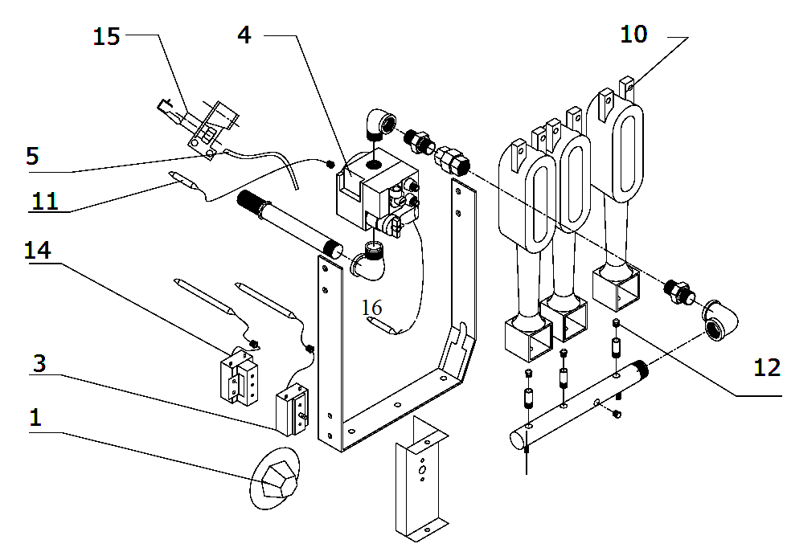

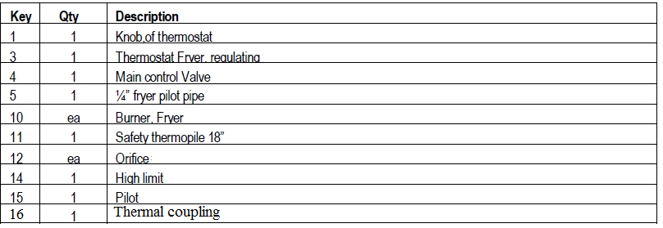

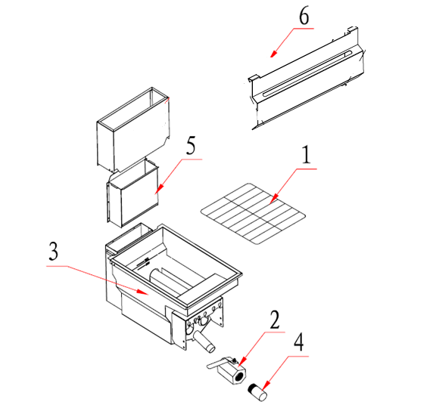
Key | Qty | Description
1 | 1 | Screen, crumb, 3 and 4 tube fryer
2 | 1 | Drain cock
3 | 1 | Tank(excluding flue)
4 | 1 | Drain, extension
5 | 1 | Flue, top, removable
6 | 1 | Flue, wrap, top, removable

Wiring diagram
